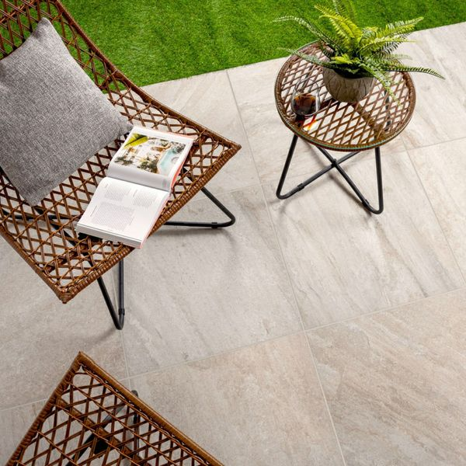

Icaria Plus Beige Porcelain Paving Slabs: <https://www.wallsandfloors.co.uk/icaria-plus-beige-595x595x20-tiles>

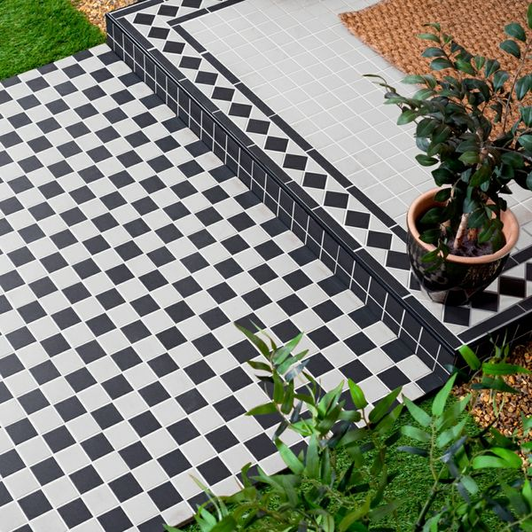

Churchill Snow & Midnight Chequer Mosaic Tiles: <https://www.wallsandfloors.co.uk/churchill-snow-midnight-chequer-mosaic-tiles>

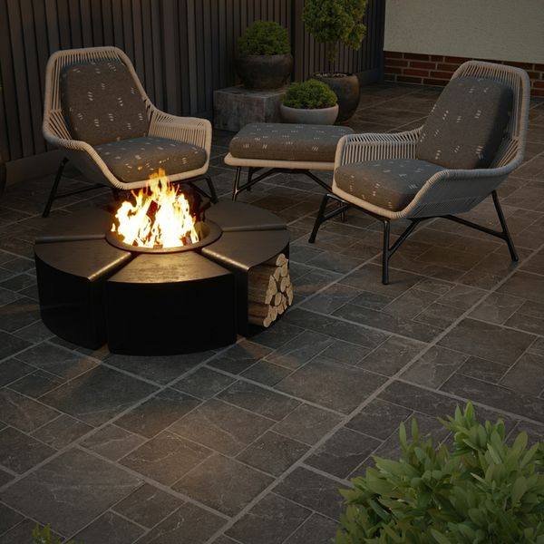

Witton Noir Porcelain Paving Slabs: <https://www.wallsandfloors.co.uk/witton-noir-60x60-20mm-slab>

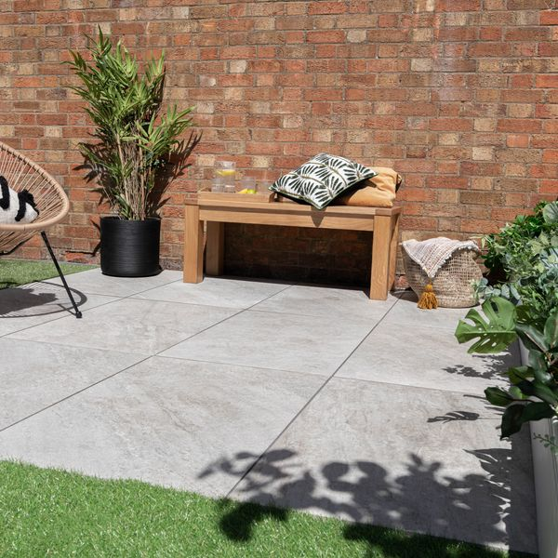

Icaria XL Blanco Porcelain Paving Slabs: <https://www.wallsandfloors.co.uk/icaria-xl-blanco-porcelain-paving-slabs>

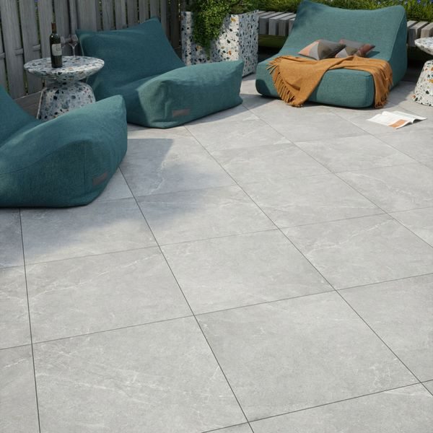

Clifton Grey 60x60 20mm Porcelain Paving Slabs: [Clifton Grey 60x60 20mm Porcelain Paving Slabs | Walls and Floors](https://www.wallsandfloors.co.uk/clifton-grey-60x60-20mm-outdoor-slab-tiles)

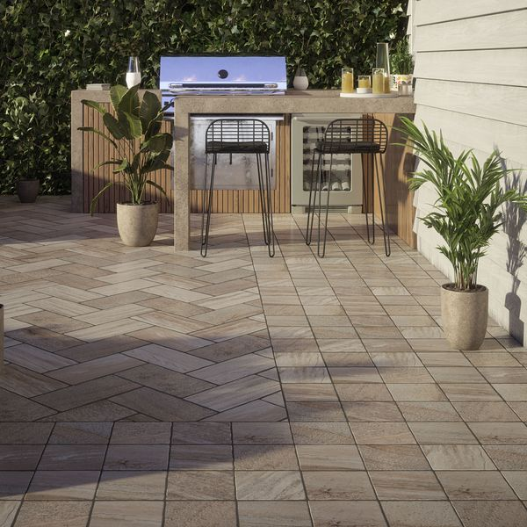

Trail Quartzita 20x20 Matt Slab Tiles: <https://www.wallsandfloors.co.uk/trail-quartzita-20x20-matt-slab-tiles>